1)Create one VPC in N.virginia region.
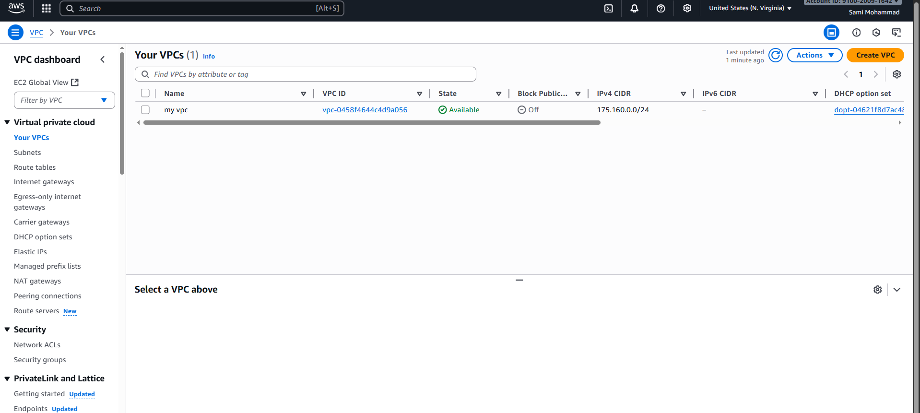
2)Create two subnets. One Public subnet and one private subnet.
Go subnets and create
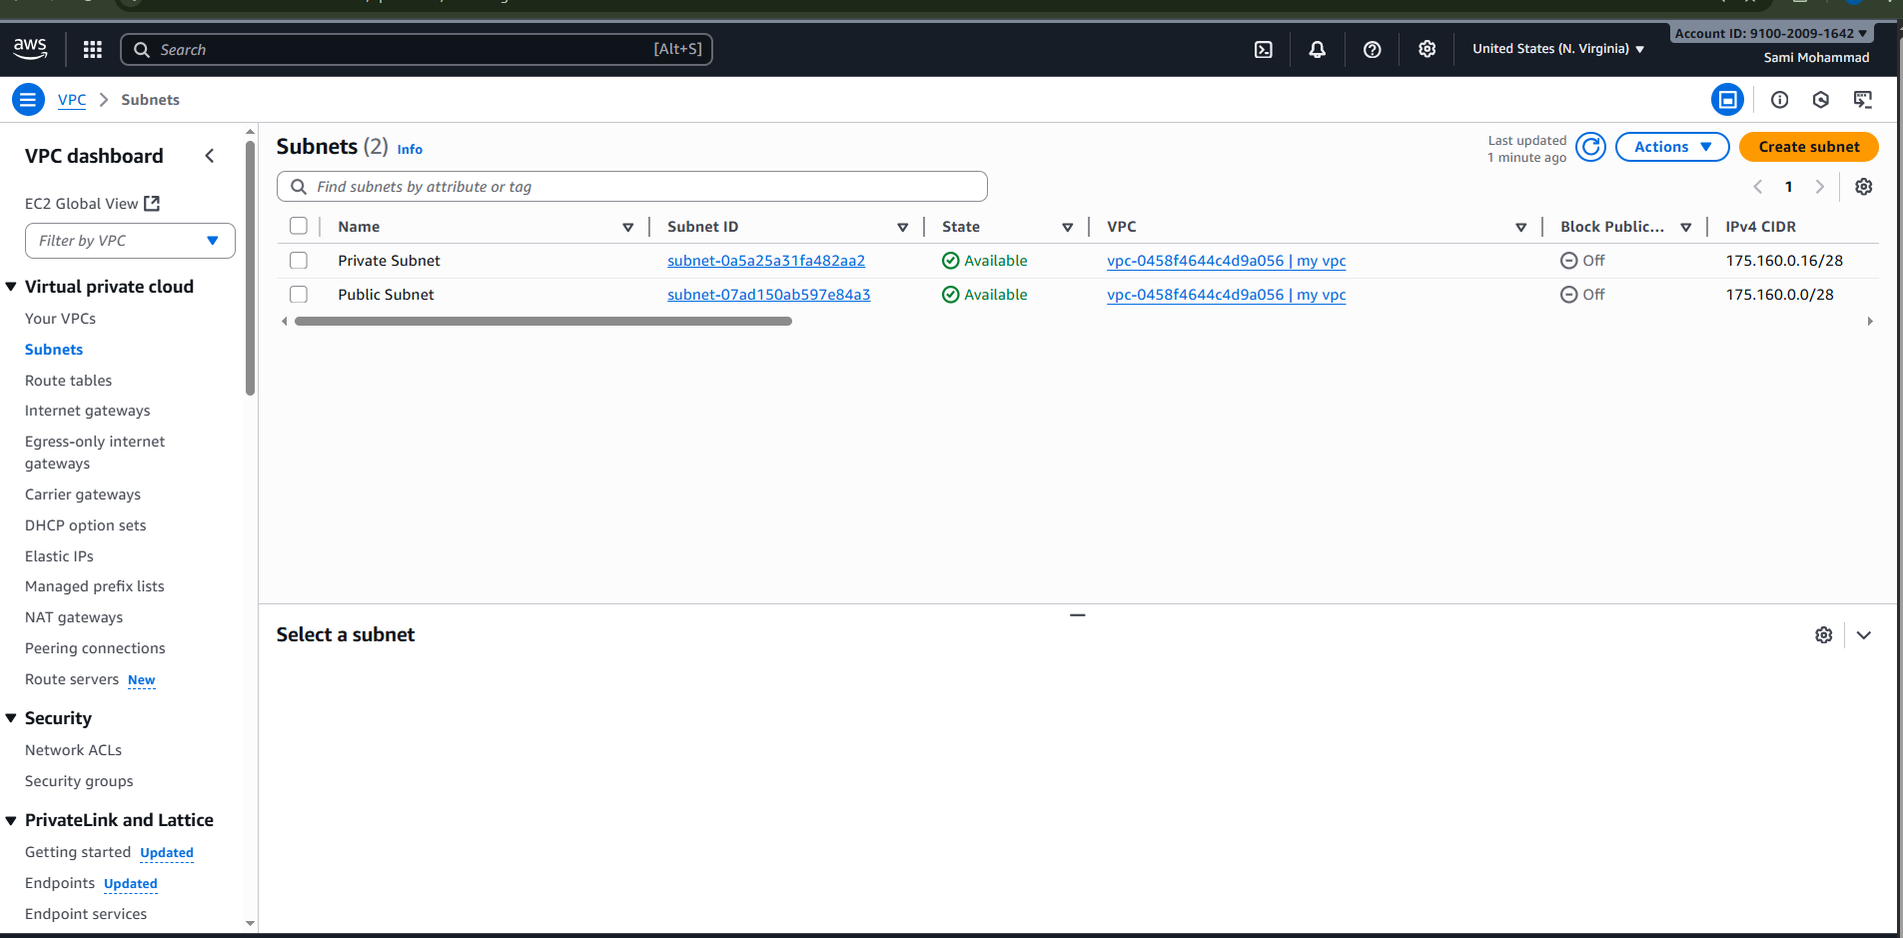
3)Provide the IGW to the vpc.
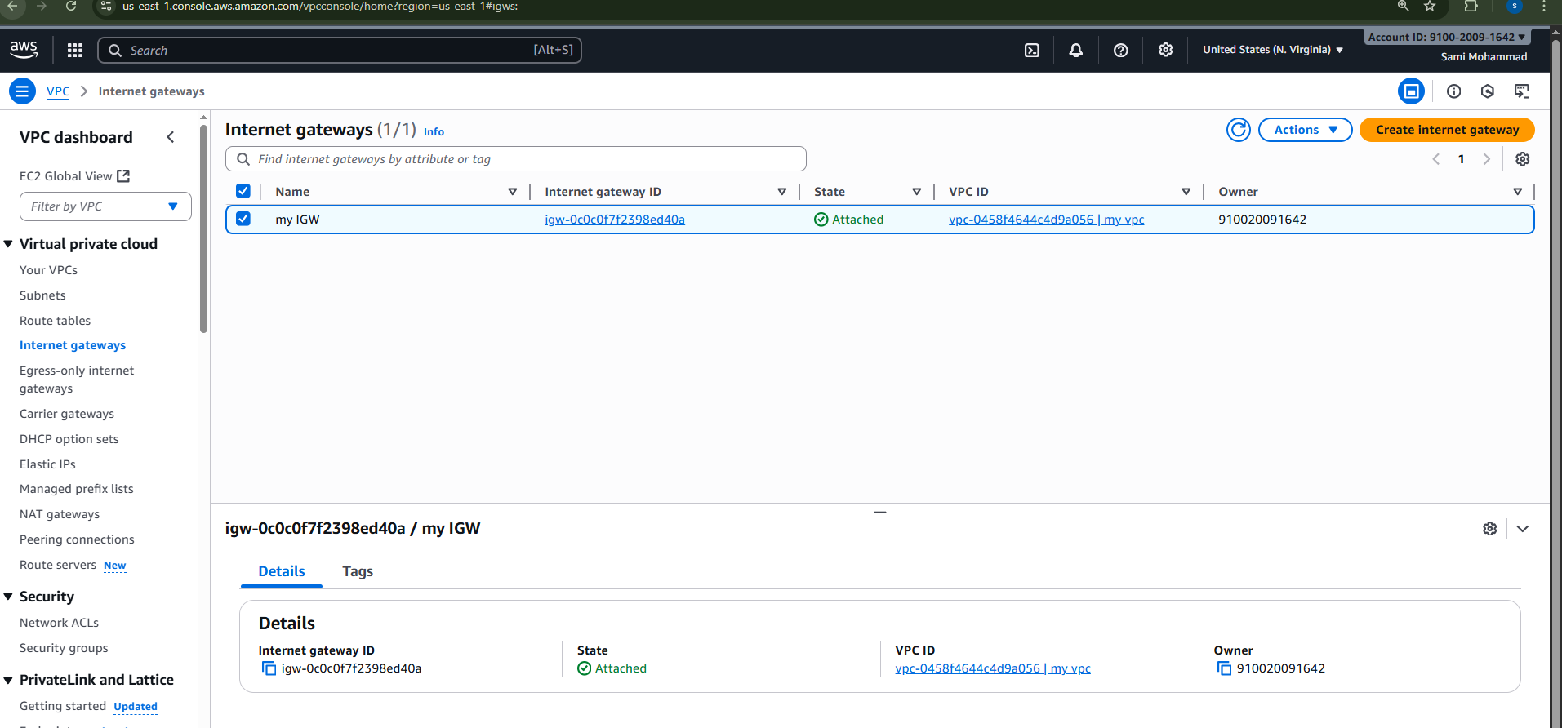
4)Create One public RT and one private RT.
Public Route Table in this we will add IGW
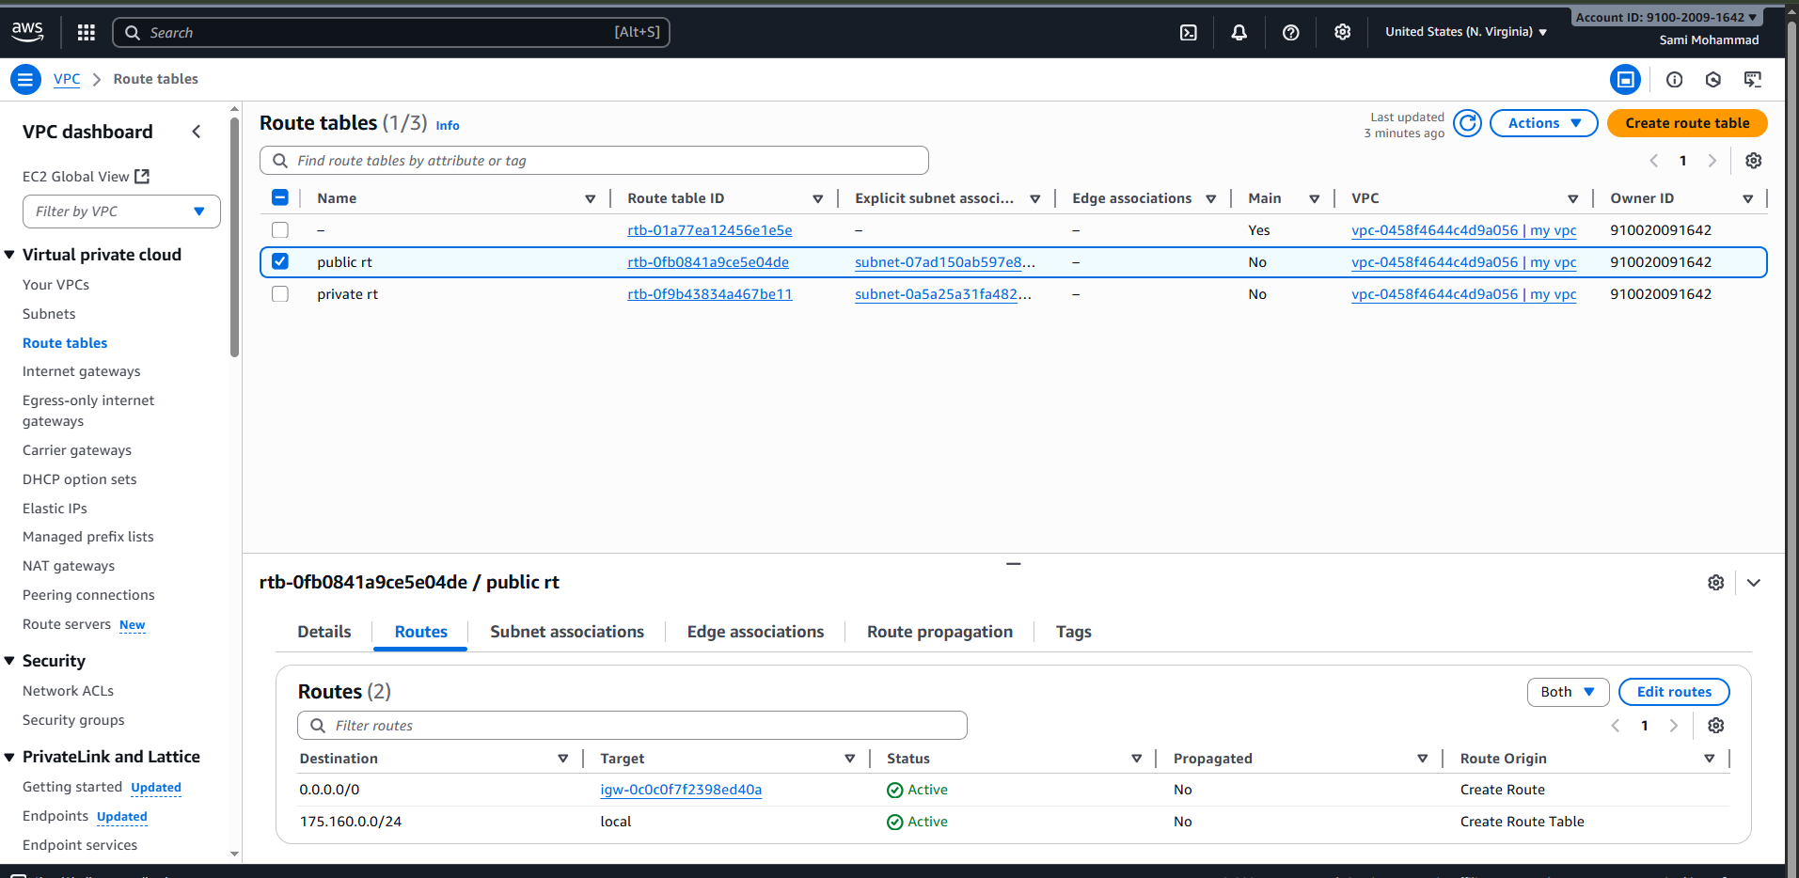
Private Route table
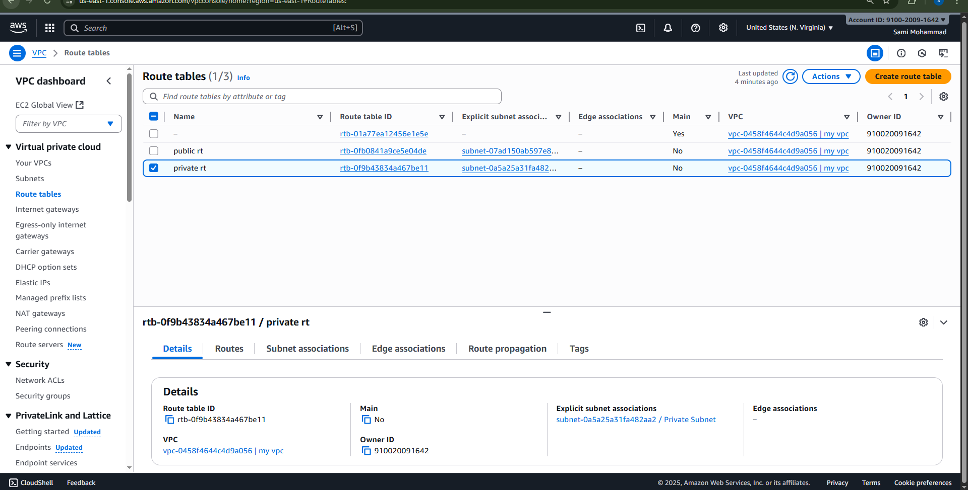
5)Deploy NAT gateway on public subnet and attach the NAT gatewat to private subnet.
1. Go to the VPC Dashboard → NAT Gateways
2. Click Create NAT gateway
3. Configure:
Subnet: Select your Public subnet (175.160.0.16/28)
Elastic IP allocation ID: Select the Elastic IP you just
allocated
4. Click Create NAT gateway
It may take a few minutes to become available.
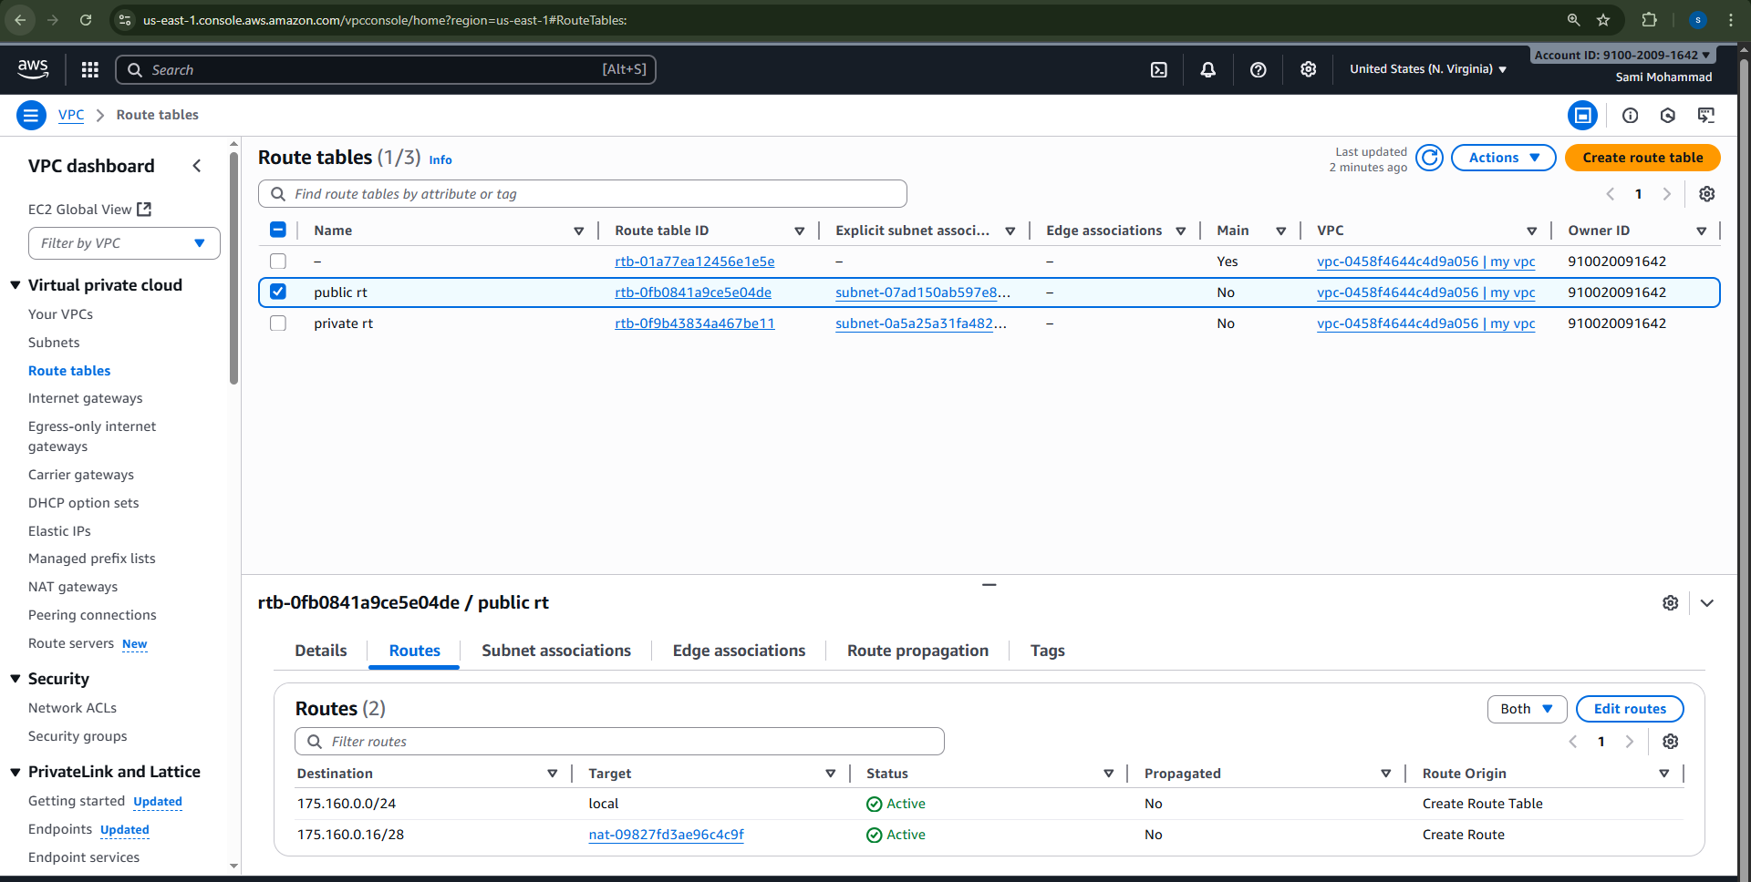
6)Create Two instances,one in public subnet and one in private subnet.
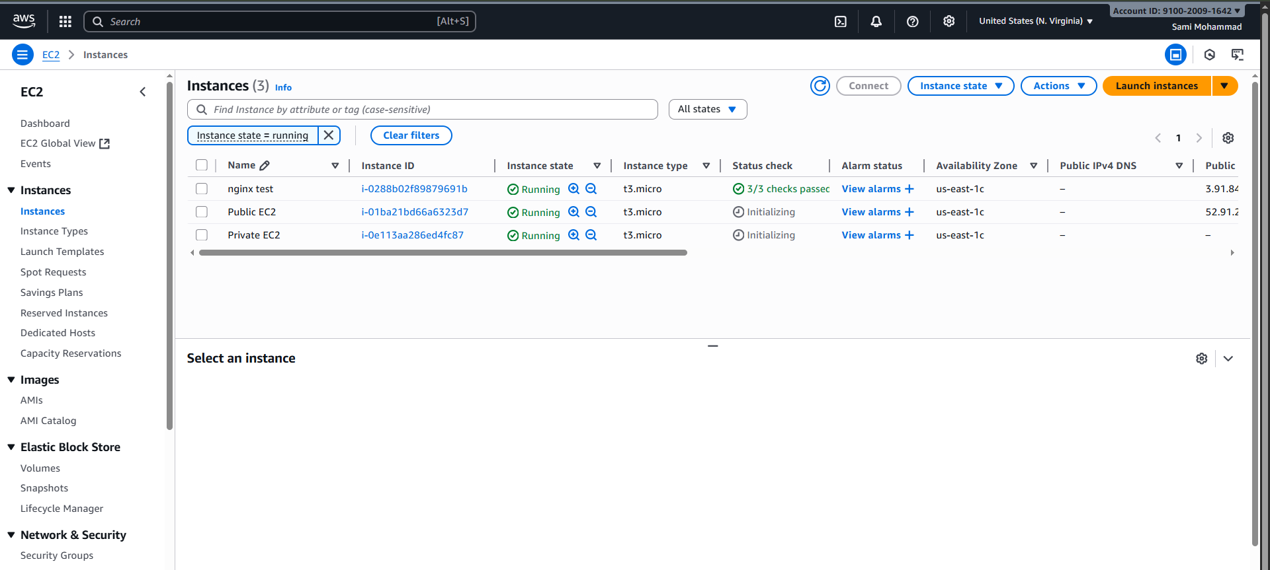
7) Deploy Apache server on both the ec2 instances with sample index.html file
Public Instance
Connect with ssh -i first-server.pem ec2-user@175-165-0-9
Connect through baston or jump server to private EC2 Instance by using ssh –I key.pem ec2-user@175-165-0-25
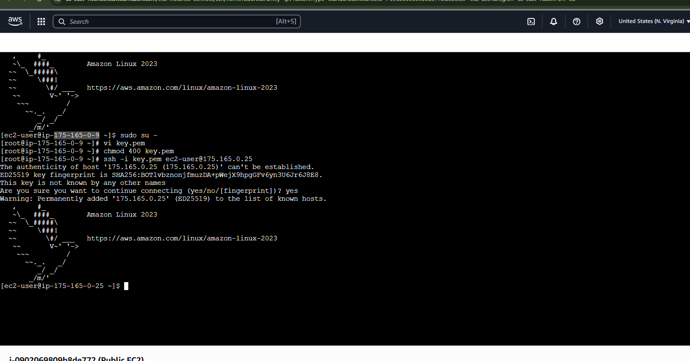Install Apache Server on Both Instances
Run these commands on both instances (public and private):
sudo yum update -y
sudo yum install -y httpd
sudo systemctl start httpd
sudo systemctl enable httpd
Installed in private EC2 instance
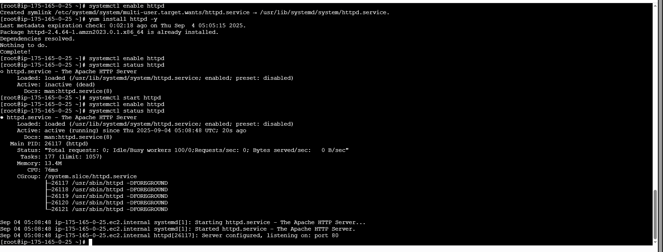
Installed in Public Instance
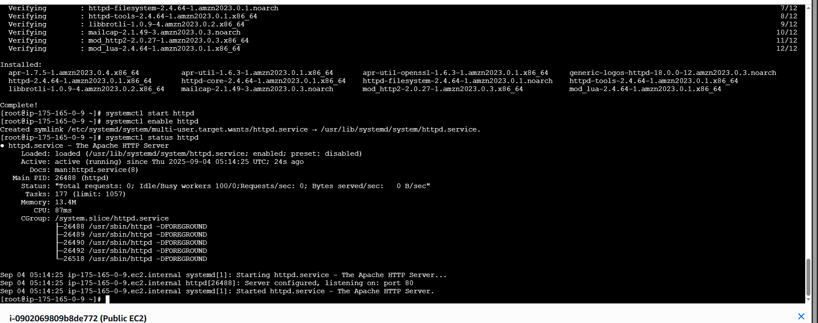

8) Create one application load balancer and attach the load balancer to both the ec2 instances.
9) Store Application load balancer logs to s3.
10) Store the VPC flow logs to CloudWatch group.
11) Create Monitoring Dashboards to monitor CPU utilization and to monitor Apache service.
12) CPU utilizations more than 70% then it should triggered Autoscaling and launch new instance.

